WEEK 3 FOOTPRINTING AND RECONNAISANCE

Fig1. DNS FOOTPRINTING
Command: nslookup google.com
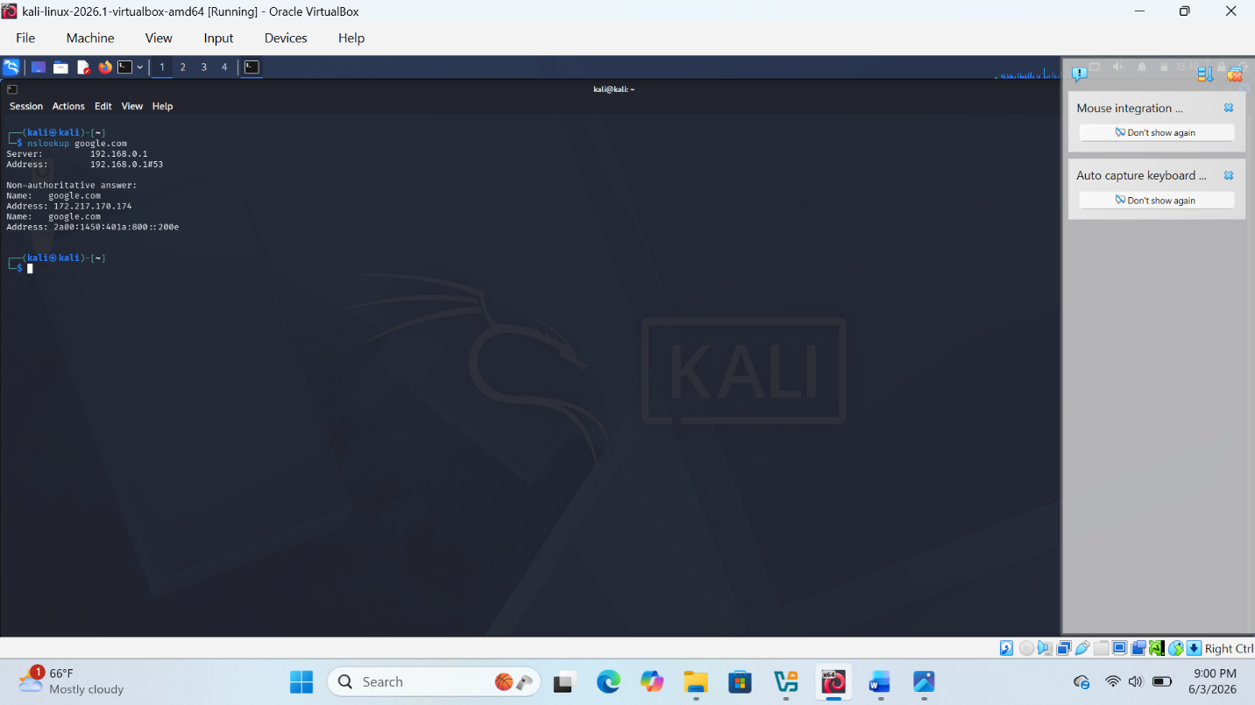

Fig 2.Social engineering footprinting
Command:theHarvester -h
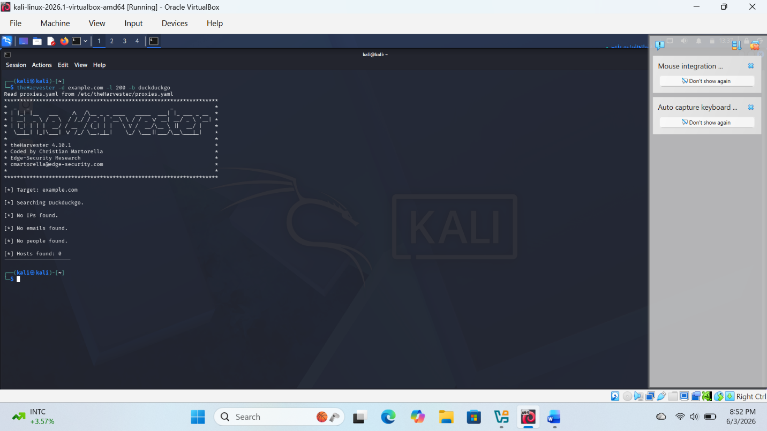

Fig 3.Hydra-password testing
Command: hydra -l admin -p rockyou.txt ssh://192.168.1.1
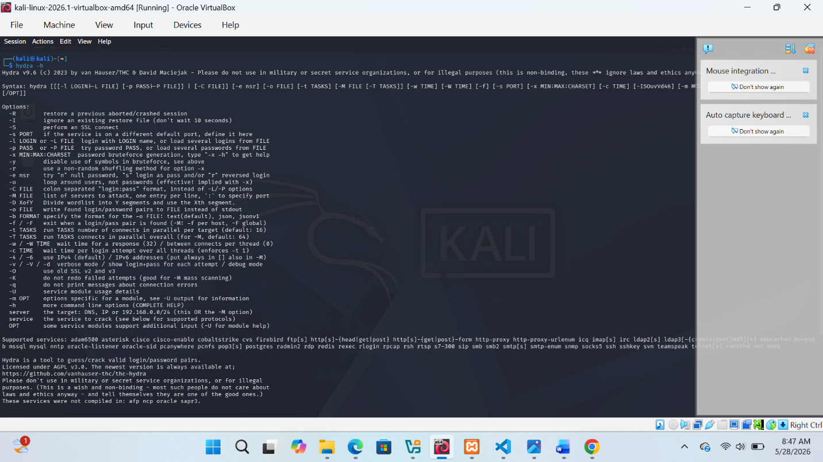

WEEK 3 STUDENT REFLECTION:
This practical exercise demonstrated basic ethical hacking techniques using Kali Linux tools. Network scanning identified active hosts and open ports, DNS footprinting revealed domain information, and theHarvester collected publicly available subdomain data. Hydra was used to demonstrate password security testing in a controlled environment. The exercise highlights the importance of securing networks, services, and user credentials to reduce vulnerability to attacks

